***Project Able: Extending our welcome***

Will you help us in our ministry and mission to be able to welcome more people from our neighbourhood in to our life together? To do this we need to extend and improve our facilities so that people with a physical disability will find us more accessible. If funds allow, we will also replace our wooden front doors with ones of glass – making our main entrance more open and welcoming. Our fundraising target is £15,000.

On the back of this leaflet a table shows how we can raise the money we need through direct donations. The form inside is for you if you would like to donate regularly rather than make a one-off gift. Please consider prayerfully and carefully the level of support you can give. Look down the table until you come to the level of donation you would like and are able to give, especially if you spread your giving over time. Then please complete the form inside and give it to Tim or one of the Deacons.

**Regular Donation Form**

*for people who want to make regular donations over time*

Help us transform our vision into

reality by lending your support to our

fundraising campaign

**Belmont Road Baptist Church**



About your donation

1. Thank you for considering making a regular donation to Project Able. Such a donation will help us plan our expenditure on the project and save money by the church paying up front from church funds and then replacing those funds with the help of your donation. You can cancel your payment at any time; if you do so, please can you let us know.

2. Should your circumstances change such that the amount of income you pay in each year is no longer equal to or more than the amount of tax that all charities you donate to will reclaim on your gifts for that year please let us know so that we do not attempt to reclaim on your gift.

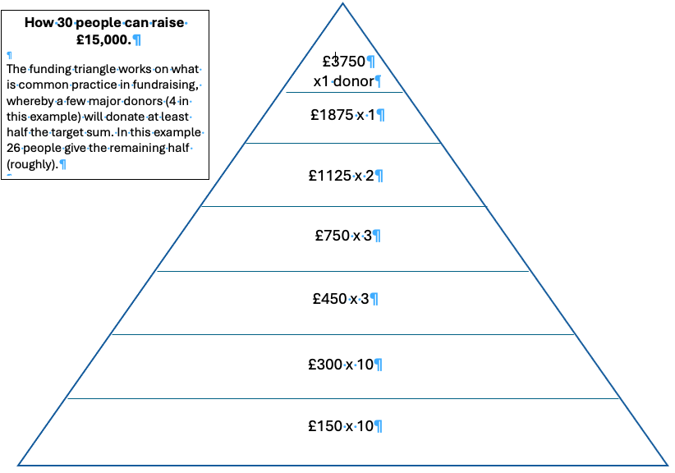

Belmont Road Baptist Church’s fundraising campaign has been carefully planned to meet the needs of Belmont Road Baptist Church and the community it seeks to serve. The right to make changes in light of altered circumstances must however be reserved by the Church Members.

Please read carefully before completing

Regular Donation

Your full name

in CAPITALS

Your full address

in CAPITALS

Postcode

I will pay direct to Belmont Road Baptist Church the sum of:

Amount in words

Amount in figures

Each month quarter year (mark one)

Date when payments are to start (this must be on or after the date of signature)

from the day of 20

Gift Aid Declaration (please tick in the box)



Please treat as Gift Aid donations all qualifying gifts

of money made from the date of this

Declaration and in the past four years. I am a UK taxpayer and understand that if I pay less income tax and/or Capital Gains Tax than the amount of Gift Aid claimed on all my donations in that tax year it is my responsibility to pay any difference. I agree to notify the church of any changes to my name, address or tax status and I understand that I can cancel this declaration at any time.

Your signature:

Date of your signature:

What to do next:

Please pay your donation into:

Bank details:

Account name: BELMONT ROAD BAPTIST CHURCH

Account No: 38553135

Sort Code: 23-05-80

Ways to donate:

• If you have on line banking, simply set up a Standing Order using the details above

• If not, please go in to your bank and arrange the Standing Order in person

£

• If you would like us to assist in completing a Standing Order form, please arrange

to see Michele or Tim.

Please send this form to us for our records. We need to keep a record of your Gift Aid

declaration. We want to manage your donation properly and to do this it helps us to

identify individual payments as they are made.

Please tick one of the following statements:

I have set up a standing order through my on-line banking

I have set up a standing order in person with my bank

I wish to complete a Standing Order Form and would appreciate the assistance of Michele or Tim or one of the Deacons.

Please give or send this form to Michele ([michele.gill@ntlworld.com)](mailto:michele.gill@ntlworld.com)) or Tim Keightley (minister.belmontroadbaptist@gmail.com)

Belmont Road Baptist Church, Belmont Road, Hemel Hempstead, HP3 9NU